Truncated Triangular Pyramid

Definition
# Source: AI Source: Provided by: [Data Path: Persons Table -> ID Column: 1, Name_En Column: Motasem Essam] -> From: [ChatGPT] on [7/25/2026]
A Truncated Triangular Pyramid is a solid formed by cutting off the apex of a triangular pyramid (tetrahedron) with a plane, usually parallel to its triangular base.
The resulting solid is called a Triangular Pyramid Frustum or Truncated Tetrahedron in the general pyramid-frustum sense.
The parallel cut produces two triangular bases of different sizes, connected by three trapezoidal lateral faces.
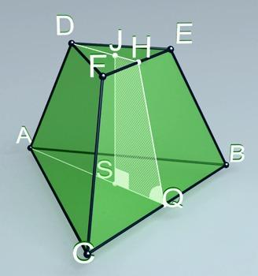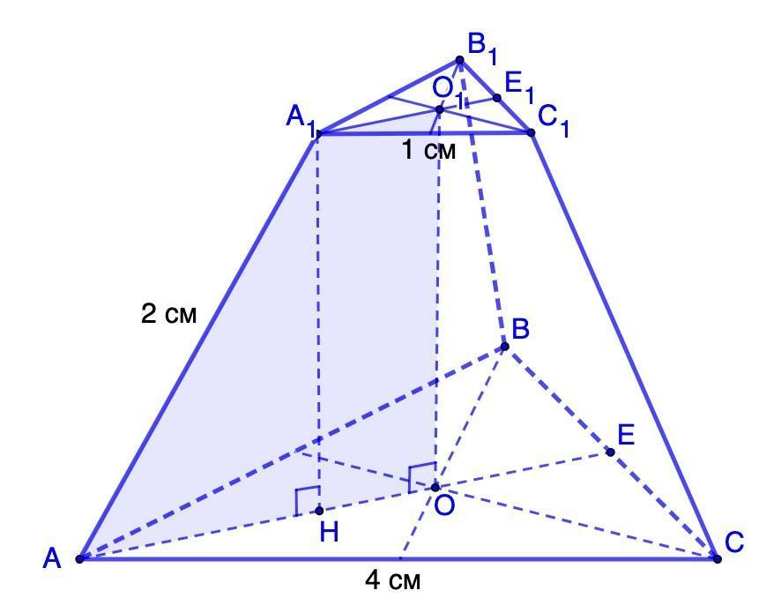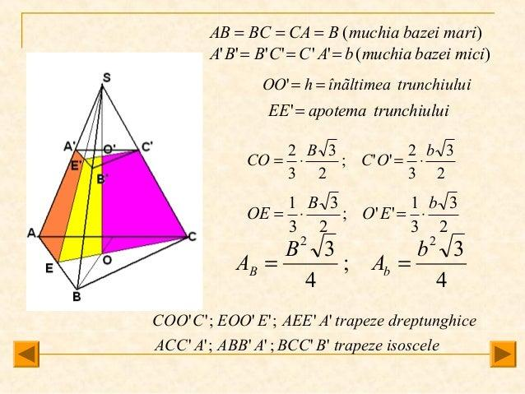

Geometric Structure
# Source: AI Source: Provided by: [Data Path: Persons Table -> ID Column: 1, Name_En Column: Motasem Essam] -> From: [ChatGPT] on [7/25/2026]
A triangular pyramid originally consists of:
- 1 Triangular Base: The bottom face.
- 3 Triangular Lateral Faces: Meeting at the apex.
- 4 Vertices: Three base vertices and one apex.
- 6 Edges: Three base edges and three lateral edges.
After truncation:
- The original base remains unchanged.
- A smaller triangular face is created by cutting off the apex.
- The three original lateral triangular faces become trapezoidal faces.
- The original apex is removed.

Face Composition
# Source: AI Source: Provided by: [Data Path: Persons Table -> ID Column: 1, Name_En Column: Motasem Essam] -> From: [ChatGPT] on [7/25/2026]
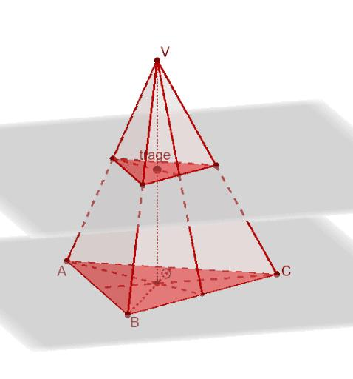

Large Triangular Base
# Source: AI Source: Provided by: [Data Path: Persons Table -> ID Column: 1, Name_En Column: Motasem Essam] -> From: [ChatGPT] on [7/25/2026]
The original base of the triangular pyramid.

Small Triangular Base
# Source: AI Source: Provided by: [Data Path: Persons Table -> ID Column: 1, Name_En Column: Motasem Essam] -> From: [ChatGPT] on [7/25/2026]
The new face created by the cutting plane parallel to the original base.

Trapezoidal Lateral Faces
# Source: AI Source: Provided by: [Data Path: Persons Table -> ID Column: 1, Name_En Column: Motasem Essam] -> From: [ChatGPT] on [7/25/2026]
The remaining portions of the original triangular lateral faces.
Total face composition:
- 2 Triangular Faces.
- 3 Trapezoidal Faces.
- 5 Faces in total.

Mathematical Properties
# Source: AI Source: Provided by: [Data Path: Persons Table -> ID Column: 1, Name_En Column: Motasem Essam] -> From: [ChatGPT] on [7/25/2026]
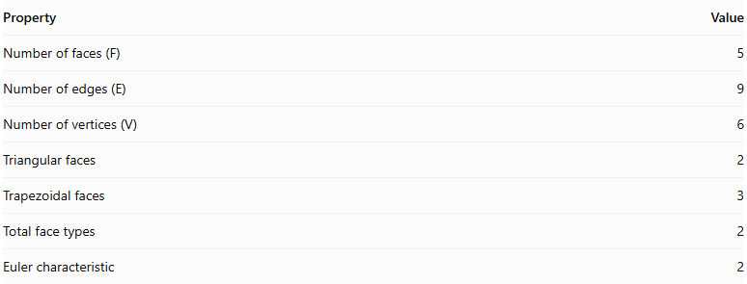
Property | Value
Number of faces (F) | 5
Number of edges (E) | 9
Number of vertices (V) | 6
Triangular faces | 2
Trapezoidal faces | 3
Total face types | 2
Euler characteristic | 2
Euler's Formula
$$V-E+F=2$$
$$6-9+5=2$$
Volume Formula
The volume of a pyramid frustum is:
$$V=\frac{h}{3}(A_{1}+A_{2}+\sqrt{A_{1}A_{2}})$$
Where:
- $h$ = perpendicular distance between the two triangular bases.
- $A_{1}$ = area of the larger triangular base.
- $A_{2}$ = area of the smaller triangular base.

Constructing Truncated Triangular Pyramid in Solid

Instruments Used
# Source: AI Source: Provided by: [Data Path: Persons Table -> ID Column: 1, Name_En Column: Motasem Essam] -> From: [ChatGPT] on [7/25/2026]
The construction uses physical geometric drawing instruments rather than coordinate-based methods.
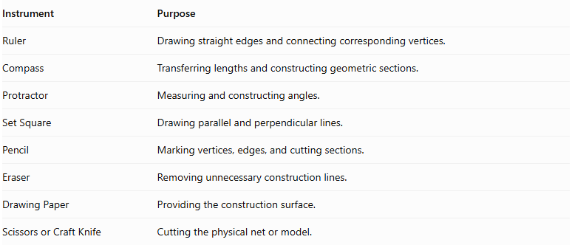
Instrument | Purpose
Ruler | Drawing straight edges and connecting corresponding vertices.
Compass | Transferring lengths and constructing geometric sections.
Protractor | Measuring and constructing angles.
Set Square | Drawing parallel and perpendicular lines.
Pencil | Marking vertices, edges, and cutting sections.
Eraser | Removing unnecessary construction lines.
Drawing Paper | Providing the construction surface.
Scissors or Craft Knife | Cutting the physical net or model.

Construction Procedures

Original-Pyramid-Based Construction
# Source: AI Source: Provided by: [Data Path: Persons Table -> ID Column: 1, Name_En Column: Motasem Essam] -> From: [ChatGPT] on [7/25/2026]
- Draw a triangular pyramid using a ruler and other geometric instruments.
- Identify its three base vertices and apex.
- Mark three points on the lateral edges at corresponding proportional positions.
- Connect these points to form a triangular section parallel to the original base.
- Remove or omit the upper portion of the pyramid.
- Complete the three trapezoidal lateral faces.
- Darken the visible edges and use dashed lines for hidden edges.

Base-Based Construction
# Source: AI Source: Provided by: [Data Path: Persons Table -> ID Column: 1, Name_En Column: Motasem Essam] -> From: [ChatGPT] on [7/25/2026]
- Draw the larger triangular base.
- Construct a smaller similar triangular base parallel to it.
- Position the smaller base above the larger base.
- Connect corresponding vertices of both triangles.
- Complete the three lateral trapezoidal faces.
- Check that the upper and lower bases are parallel and similar.

Vertex-Connection Construction
# Source: AI Source: Provided by: [Data Path: Persons Table -> ID Column: 1, Name_En Column: Motasem Essam] -> From: [ChatGPT] on [7/25/2026]
- Mark the three vertices of the lower triangular base.
- Mark the three vertices of the upper triangular base.
- Connect corresponding lower and upper vertices.
- Connect consecutive vertices of each base.
- Verify that the solid has six vertices and nine edges.

Edge-Based Construction
# Source: AI Source: Provided by: [Data Path: Persons Table -> ID Column: 1, Name_En Column: Motasem Essam] -> From: [ChatGPT] on [7/25/2026]
- Draw the three edges of the lower triangular base.
- Draw the three edges of the upper triangular base.
- Construct the three lateral edges connecting corresponding vertices.
- Complete the three trapezoidal lateral faces.

Face-Based Construction
# Source: AI Source: Provided by: [Data Path: Persons Table -> ID Column: 1, Name_En Column: Motasem Essam] -> From: [ChatGPT] on [7/25/2026]
- Construct the lower triangular base.
- Construct the upper triangular base parallel to it.
- Draw three trapezoidal lateral faces between the bases.
- Connect all corresponding edges.
- Ensure that the five faces form a closed solid.

Net-Based Construction
# Source: AI Source: Provided by: [Data Path: Persons Table -> ID Column: 1, Name_En Column: Motasem Essam] -> From: [ChatGPT] on [7/25/2026]
- Draw one larger triangular base.
- Draw one smaller similar triangular base.
- Construct three trapezoidal lateral faces around the bases.
- Add tabs if necessary for physical assembly.
- Cut out the net.
- Fold the trapezoidal faces and join their corresponding edges to form the truncated triangular pyramid.
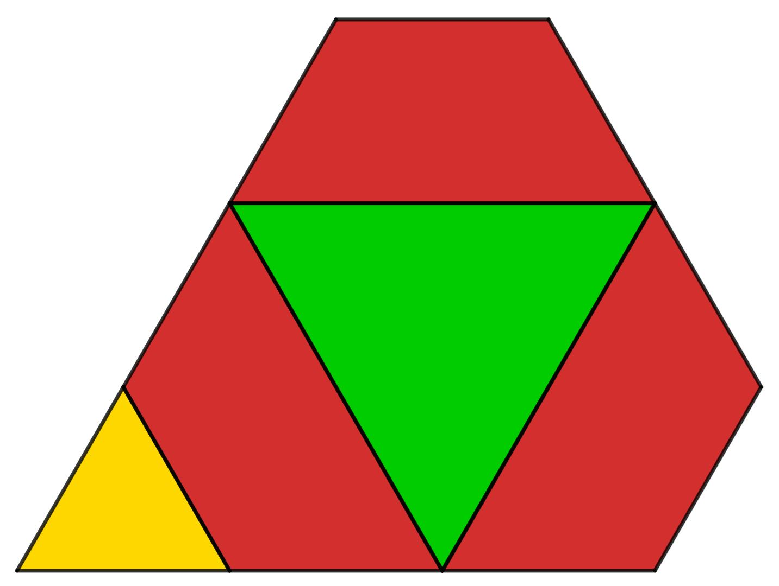

Key Points
# Source: AI Source: Provided by: [Data Path: Persons Table -> ID Column: 1, Name_En Column: Motasem Essam] -> From: [ChatGPT] on [7/25/2026]
- It originates from a triangular pyramid.
- It is formed by cutting off the apex, usually with a plane parallel to the base.
- It has two parallel triangular bases.
- It has three trapezoidal lateral faces.
- It contains 5 faces, 9 edges, and 6 vertices.
- It is a type of triangular pyramid frustum.
Important terminology distinction:
A triangular pyramid is also a tetrahedron. If all four vertices are truncated, the result is a different solid: the Truncated Tetrahedron, which has 4 triangular faces and 4 hexagonal faces.
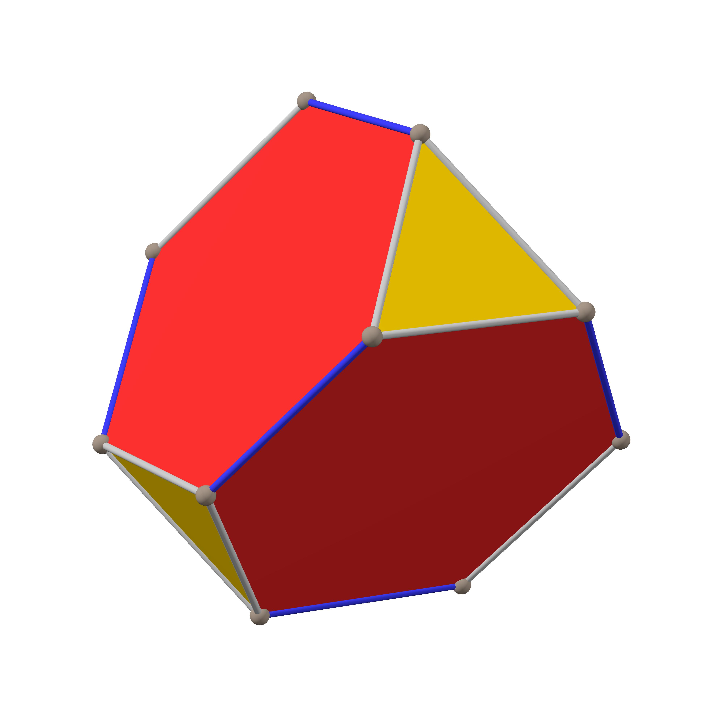

Conclusion
# Source: AI Source: Provided by: [Data Path: Persons Table -> ID Column: 1, Name_En Column: Motasem Essam] -> From: [ChatGPT] on [7/25/2026]
The Truncated Triangular Pyramid is a triangular pyramid with its apex removed by a plane parallel to its base. It forms a triangular frustum consisting of two triangular bases and three trapezoidal lateral faces, with 5 faces, 9 edges, and 6 vertices.

